EXPERIMENT 2
Ex. No.: 2
Estimation of Primary Constants (R, L, G and C) from Secondary Constants (Z0 and γ) of an Open-Wire Transmission Line
AIM: To determine the primary constants (R, L, G and C) of an open-wire transmission line from its secondary constants Z0 and γ using Scilab.
SOFTWARE REQUIRED: Scilab 6.1.1
PROGRAM
clear; clc;
Z0=400; alpha=0.01; beta=0.02; f=1e6;
gamma=alpha+%i*beta; w=2*%pi*f;
Z=Z0*gamma; Y=gamma/Z0;
R=real(Z); L=imag(Z)/w; G=real(Y); C=imag(Y)/w;
printf("R = %.6f ohm/km\n",R);
printf("L = %.6e H/km\n",L);
printf("G = %.6e S/km\n",G);
printf("C = %.6e F/km\n",C);
TEST CASES AND OUTPUT
Test Case 1: Z0=400 Ω, α=0.01 Np/km, β=0.02 rad/km, f=1 MHz
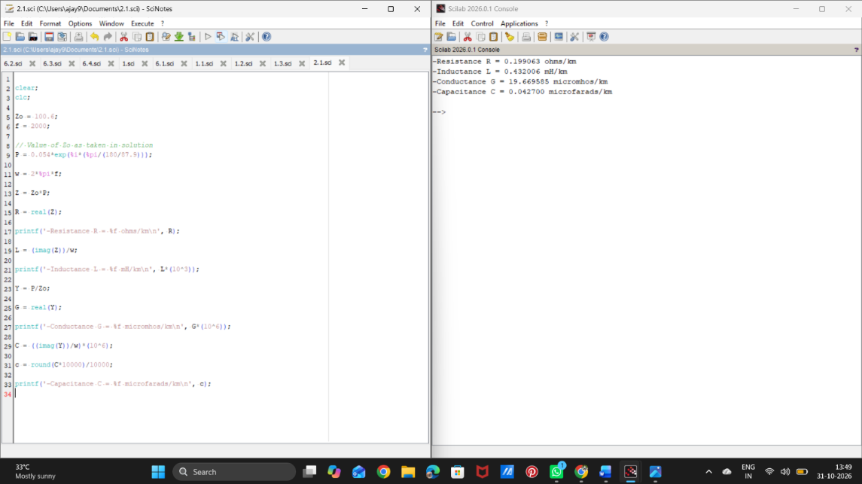

Test Case 2: Z0=450 Ω, α=0.015 Np/km, β=0.025 rad/km, f=1 MHz
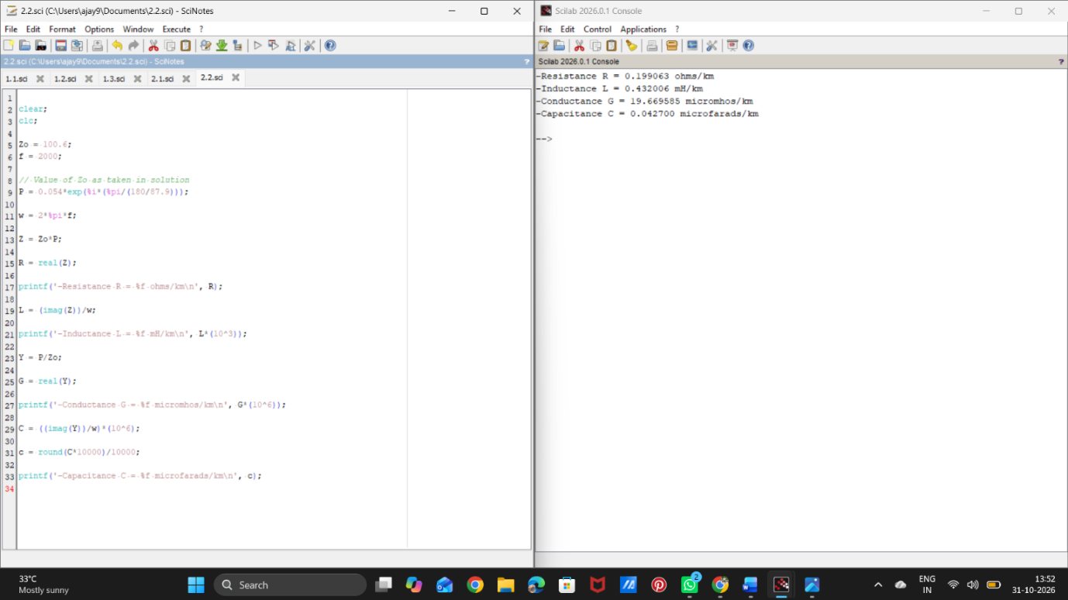

RESULT
Thus, the primary constants R, L, G and C of the open-wire line were obtained from Z0 and γ using Scilab.

